**Car Dashboard**

The Power BI dashboard is a comprehensive data visualization designed to provide insights into various aspects of car data. It enables users to explore and analyze data related to car brands, company names, departments purchase dates and more.

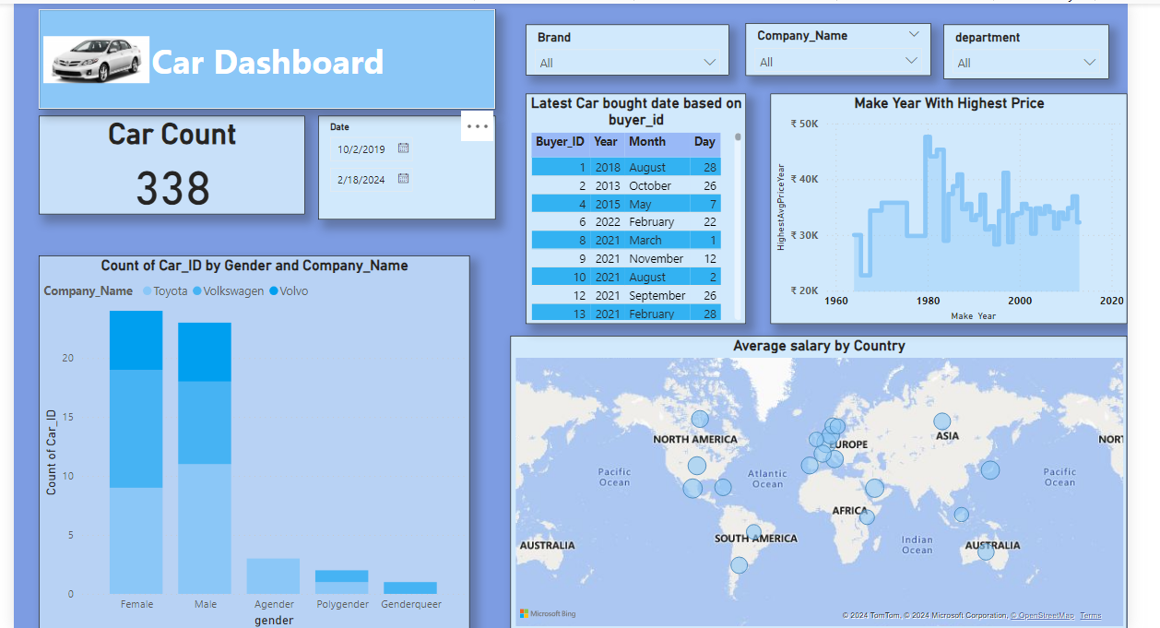

**Slice Filters:**

Users can filter the data dynamically including brand, company, name, departments and purchase date. I created them by selecting the fields (such as brand, company name, department and purchase date from the given dataset and adding them to the slicer visualization.

**Latest Car Bought Date based on Buyer:**

Use DAX to create a calculated column that calculates the latest car bought date for each buyer_id. Here I use functions like CALCULATE and MAX to find latest car bought date for each buyer_id. Here I use Table visualization to show the day, month and year the car bought by a particular buyer.

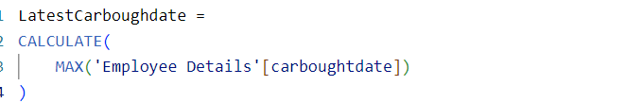

**Make Year with Highest Price:**

Here I have created an area chart to show highest price on a particular year. Use DAX measures to calculate the average price for each make year.

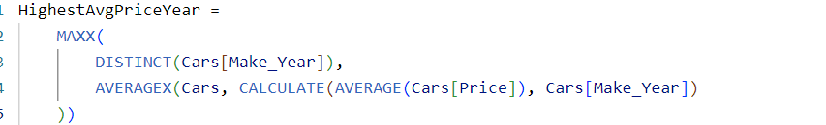

**Average Salary by Country:**

Here I visualize the data using Map chart where in location I kept the country and in bubble size I kept the average salary.

Count of Car_ID by Gender and Company Name:

Create a visualization, such as a stacked column chart, that shows the count of car IDs segmented by gender and company name. Here in x axis I have put Gender, in y axis count of Car_ID and in legend Company Name and visualize the data.

**Insights about the car market and customer behavior**

**High Salary in Europe:**

Knowing that Europe has the highest salary indicates that it might be a lucrative market manufacturers. It suggests that consumers in Europe may have greater purchasing power, which could influence pricing strategies and marketing efforts targeted at this region.

**Popular Car Brands Across Genders:**

Toyota, Volkswagen and Volvo as the most used cars for both men and women suggest these brands have widespread appeal and acceptance among diverse demographic.